**Engineering Test Procedure (ETP):**

**(Resistance to lint, dust, and oil accumulation)**

**Loading Conveyor:**

1. Measure 100 grams of lint and 16 grams of dust
2. Place both lint and dust into the 1-gallon paint can. Shake vigorously.
3. Place contents into the lift sifter.
4. Place 10-inch-long tray underneath lint sifter and turn sifter “ON”
5. Dispense 12 grams of mixture into the 10-inch-long tray
6. Place contents onto the conveyor belt
7. Place 33 grams of dust into the same 10-inch-long tray. (Uniformly distributed)
8. Place the dust on top of the mixture that is currently on the belt.
9. Repeat until the belt is loaded

**Water heater Setup:**

1. Install water heater per Figure 1 and Figure 2
2. Place Flue Sample Tube into flue exhaust and connect to Siemens Ultramat 23 CO/CO2 analyzer
3. Connect manifold pressure tubing to pressure transducer
4. Turn Pump “ON” for Siemens Ultramat 23
5. Verify there is no condensate in the flue gas sampling tube and condensate trap on the combustion analyzer
6. Turn blower “ON” and verify 80 ± 4 CFM
7. Fill water heater with 70 ± 2 ºF water
8. Verify water pressure while flowing is 40 PSI
9. Document the oil container level,
10. Verify desiccant in flue gas sampling line is dry, the vent exhaust blower is running, and LDO room pressure and temperature are within allowable limits.
11. Verify there is no water or gas leak
12. Light pilot and set thermostat to the highest setting
13. Connect the Vesta tool cable to the “COM” port in the gas thermostat. Launch the Vesta software on the computer. Select the correct com port and appropriate parameters. Verify the water heater is communicating with the Vesta software.

See below image for the values that needs to be recorded on Vesta Software. 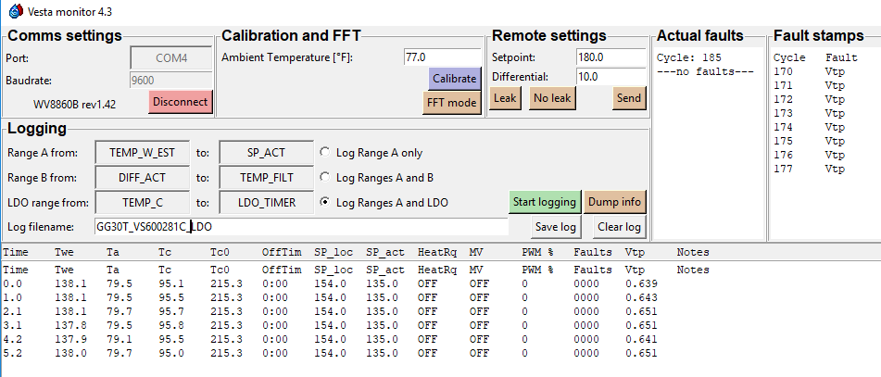

1. With Burner “ON”, adjust inlet pressure to nominal inlet gas pressure (7.0±0.3 inches of water)
2. Allow water heater to heat for a minimum of 30 minutes. This will remove machining oils from the manufacturing process and establishes the door Tc0 set point.
3. Turn water heater “PILOT” ~~and let the burner cool~~
4. Fill water heater with 70 ± 2 ºF water
5. Set thermostat to the highest setting
6. Perform the ANSI 15 minute rate test at nominal inlet gas pressure (7.0±0.3 inches of water)
   1. Verify water heater rate of unit is ± 2% from the nameplate rating
   2. Verify AFCO does not exceed 0.04%
   3. Record and Export the ANSI 15 minute rate test to a .CSV file
7. Verify the main burner on the water heater is “ON”
8. Press “Start” on the automated software to start LDO test

**End of Test:**

1. Review gas valve error code list and document which error code is blinking. Record this error on the final submittal sheet.
2. If required, reset the water heater gas thermostat and run an ANSI 15 minute rate test.
3. Record and Export the ANSI 15 minute rate test to a .CSV file.
4. Robocopy Full LDO Test Data to network.
5. Shut system down and clean areaAnalyze Data Using the Water Heater Analysis Tool.
6. Submit Test report and data for Engineering Review

**Figure 1:**